1. THE DESCRIPTION OF WORK

Aflatoxins are a group of mycotoxins which are toxic metabolites of certain filamentous fungi and they cause some dangerous health problems such as immunosuppression and cancer. Therefore detecting aflatoxin contamination on agricultural foods and separating contaminateds from uncontaminated ones is very crucial.

In our project we will detect aflatoxin contaminated products and select them to separate. We will use computer vision based system to accomplish this task which is faster and cheaper then other ways.

We are planning to use some mask and filter first to get a better image, then use some methods to extract features which will help to separate the foods.
Our system will read image of food under uv light then will apply some filters and masks to get a better image. then use some methods to extract features which will help to separate the foods. After that we are planning to apply threshold and get a binary image which will show the aflatoxin areas. Next step is using some morphologic operations to make aflatoxin areas more closed. Finally we are planning to draw counters around these closed areas which represents aflatoxin contaminated areas.

We are building the project for MET Technology and the UV light and camera system will be provide by them. The project system will be mount at the and of an industrial microwave oven which is developed by the company company. Software for selection is our work.

We are planning to separate aflatoxin contaminated foods which come from a microwave oven on a band. The product will enter a closed box which includes our camera and uv system. In the box camera will take the image frame by frame and send it to computer. In the computer the software which we are working on will detect the aflatoxin and send a coordinate of that product. After the product exits the box a air machine will send air to that coordinate to send the contaminated product to another box. And the good products will flow through line.

We will use OpenCV library and Python language. Since we do not have any camera and uv setup at the beginning we will work on some sample images which is on the internet.

In our project we will test our project with three type of images. These are images find from internet, images suplied by people who worked on similar project and actual data from our setup. We are planning to prepare a program at early stages and after each test we want to improve the results by changing the program. And after last updates using the software professionally.

Our first tasks are understanding basics of image processing and learning how to use OpenCV and Python. Then making some research on web to find similar projects. After that we need to analyze and determine the requirements. Next task is implementation. And testing is our last task. However we have multiple implementation and test tasks for different test stages.

Wp no | Work package title | Start | End | Duration
1 | Understanding basics of image processing
2 | learning how to use opencv and python
3 | research on similar projects
4 | Analyze and determine requirements
5 | Implementation 1 (image processing)
6 | Implementation 2 (graphical user interface)
7 | Test

1.Understanding basics of image processing

Research, reading and exercising about fundamentals of image processing such as pixelwise operations, filters, thresholding, histograms etc.

2.learning how to use opencv and python

Reading documentation of opencv and making some examples and exercises on Python Programming Language. Learning OpenCV’s reading, showing writing, filtering, closing functions etc.

3.research on similar projects

Objective:have idea about similar project and how they work

Research on similar projects which uses image processing to detect aflatoxin contamination on foods. Analyze their approach to develop our system.

4.Analyze and determine requirements

Objective:Getting a brief project goal

Analyzing requirements which given by the company and deciding which are functional and which are nonfunctional.

5.Implementation

Objective:Implementation of project

The project will be implemented as two parts. First part is image processing part which will do the main work of project. And second part is graphical user interface part which is a simple interface between user and program.

6.Test

Objective: Testing and debugging the program

In this task we will test the software which we have done in implementation task. We will measure the accuracy rate of our program with our camera and UV setup.

Test report

methodology and analysis

feas

The project is based on reading images, processing them and finally getting an output. Here is the hardest part is sending the output to air machine which the company will use to sort out the products because they must be coordinated with each other, but can solve by trying and testing. And other parts are already in use in our lives. So we can say our project is feasible.

As a process model we will use waterfall software development model. The reasons to choose this model is

it is easy to manage
when process is completed no need to go back
task separation

the model has 6 steps which are requirement elicitation & analysis, design, implementation, test, deploy and maintenance.
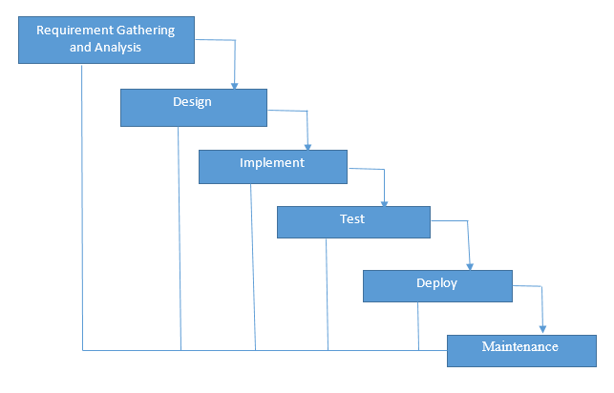

Our functional requirements are:
When the machine has started the camera starts to read frames of stream
System will look for any contamination
When it find the aflatoxin contamination on frame it will send the coordinate of it to the air machine.
After seperation is done number of contaminated products will be shown.

And non functional requirement is creating graphical user interface by this user can control some options.

Analysis model is shown in figure. Camera output will taken by computer as input and after processing the coordinate data will be send to the air machine.

We are planning to solve the problem of separating aflatoxin contaminated products. For this purpose we will use image processing techniques under UV light. We use UV light because aflatoxin became very apparent under it.
------resim.
First we will read the stream frame by frame and apply a binary filter with a threshold value and get a binary image. Then if amount of aflatoxin is more than limits we will discard it and send the coordinate of it to air machine.

We will use OpenCV 3.0 python library and Python Programming Language 2.7 for the project.

Currently aflatoxin detection on foods is usually done by chemical ways. However these systems are expensive and time consuming. As another method spectrophotometers have been used to identify aflatoxin contamination which uses near infrared (NIR) frequency bands, but this is also a time consuming operation and requires expensive instruments. Also there are some works done with UV light:

In “Development of a UV-based Imaging System for Real-Time Detection and Separation of Dried Figs Contaminated with Aflatoxins” article of Ö.B. ÖZLÜOYMAK is also using a image processing technique under UV light but they are interested in only figs we are planning to work with different type of foods.

In “A new approach to aflatoxin detection in chili pepper by machine vision” by M. Ataş, Y. Yardimci and A.Temizel, they are using neural network to detection aflatoxin we will not use this technique.

Also H. Kalkan, P. Beriat, Y. Yardimci and T.C. Pearson has a article “Detection of contaminated hazelnuts and ground red chili pepper flakes by multispectral imaging”. They are use image processing and water control together to detect aflatoxin.

